Corporate Vandalism by West Berkshire Council?
Corporate Vandalism is defined as the deliberate destruction of or damage to public and private property and that’s exactly what West Berkshire Council is responsible for since they closed, without justification and against the public interest, Newbury’s only football stadium on 24th June 2018.
The pictures below show what the facility was like before it was closed 2 years ago and in contrast what it is like now – it’s a disgrace and the Council should hold its collective corporate head in shame for knowingly and deliberately creating this totally unjustifiable situation.
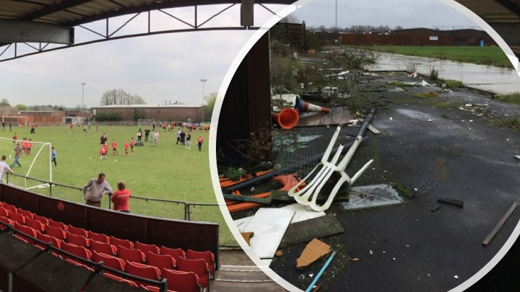
In October 2016 the Newbury Community Football Group (NCFG) succeeded in getting the Faraday Road football pitch and associated facilities listed by West Berkshire Council as an Asset of Community Value – which is unequivocal evidence of demand for use and essential value to the community. If this Council can do this to an ACV, what would it be like if it was not listed?
Why have they done it?
Despite a petition against the destruction of the ground that was signed by nearly 7,000 people the Council totally ignored it and closed it anyway. Their justification for evicting the previous operator (Newbury FC) and denying everyone access to the community ground, is that sometime in the future, they think that it would better to allow a property developer to concrete it over and put flats on the site than retain a first class football facility for the use and benefit of the community. However, 2 years after the closure of the ground they still have not submitted any planning applications or undertaken any public consultation regarding their intentions with respect to the ground. What they have done in the last 2 years is oversee and actively encourage the removal of assets from the ground (such as the main spectator stand and the perimeter fence) and leave the ground and buildings in a totally dilapidated state that has not surprisingly been further ravished by a fire and low level vandalism.
We expect that all holders of public office should act solely in terms of the public interest and that all Councils will adhere to their own, local and national planning policies. Unfortunately, this does not seem to apply to West Berkshire Council as their actions in this matter are demonstrably not in the public interest and they are definitely contrary to its own Core Strategy which clearly and expressively states:
“Existing community facilities will be protected and, where appropriate, enhanced. These include leisure and cultural facilities, which contribute to the attraction of the town for both residents and visitors.”
The Newbury Football Ground is identified as a cultural facility in Area Delivery Plan Policy 2 (ADPP2):

“the districts Green Infrastructure will be protected and enhanced” and “Developments resulting in the loss of green infrastructure or harm to its use or enjoyment by the public will not be permitted”.
The Newbury Football Ground is identified in Local Planning Policy CS.18 as a vital part of Green Infrastructure in West Berkshire;

The Council should be adhering to their own adopted policies but they’re not. Instead they are spending and wasting vast amounts of our money on a predetermined decision to build flats on the football ground without taking into account all the merits of alternative arguments that should be based on empirical evidence and what’s in the best public interest. (Predetermination occurs where someone closes their mind to any other possibility beyond that predisposition, with the effect that they are unable to apply their judgement fully and properly to an issue requiring a decision).
The Council could have avoided a lot of controversy, adverse accusations and public dismay if they had simply provided a new facility in a suitable new location, that is of equivalent or better quality than the existing Faraday Road facility, before they closed the existing ground – but they didn’t. Now, 2 years on since the closure, the ground is dilapidated, unused, boarded up with no alternative facility even identified let alone operational. It makes no sense, it’s like demolishing a perfectly good home that you live in before you’ve identified a new building plot, before you’ve bought that new plot, before you’ve got an architect to design your new house and before you’ve got planning permission to build it. It’s back to front and no one in their right mind would do it that way. As such there is absolutely no justification whatsoever for the Council in closing the existing ground when they did.
What next?
Newbury Football Ground, the only one in Newbury, has stood on the current site since 1963 and has been used by all ages across the generations. The Clubhouse has been regularly used by the community for social gatherings and club meetings for well over 50 years and its close proximity to the Town Centre makes it a great location as it provides convenient access for all age groups by a variety of means of transport.
NCFG have submitted planning applications for 3G pitches and for a replacement clubhouse / changing facilities / floodlights on the existing Faraday Road site. This planning application has the support of the Town Council, Sport England, the Football Association, the Newbury Society and earlier this year was approved by the Local Planning Authority. In addition, 2,500 people signed a petition supporting this application.
NCFG hope that our planning application will be realised but we have always been open to the option of an alternative facility but it has to be of an equal or better standard in a similar location and be able to support all teams that can and want to compete in the National League System.
As we approach the 2-year anniversary (24th June 2020) since the ground was closed, we see a simple, sensible and practical way forward, which is:

The ground should be returned to its former status (step 5 facility) without further delay and remain open and fully operational until either:

The Council has provided a replacement (and fully operational) facility in a suitable location that is of equivalent or better quality.
or
NCFG plans for a 3G pitch and new club house at the current site has been delivered.

With all the continued controversy surrounding the London Road Industrial Estate why in all honesty would the Council not accept this as a gracious and sensible way forward.

NCFG, who are we and why do we exist?
In late 2015, as a direct consequence of West Berkshire Council’s decision to close Newbury’s only community football ground, without a commitment to replace it, Newbury Community Football Group (NCFG) was formed.
NCFG is a Community Interest Company (CIC) incorporated in 2016 (Company No.10155949).
The simple objective of the CIC is to carry out activities which benefit the whole community and in particular to support and champion the provision of first class, easily accessible, football facilities for ALL groups in the local community.
Football is our national sport; it inspires young people and provides a focus for personal and physical development from early years into adulthood.

Contact - press@ncfg.uk: Paul Morgan 07767 817208 or Lee McDougall - 07836 201362

